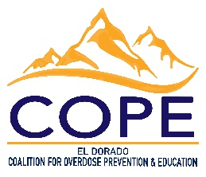

El Dorado County Narcan Distribution Sites

Barton Health | (530) 307-1066
- 2170 South Avenue, South Lake Tahoe, CA
  - Emergency Department. Walk-ins welcomed
  - At clinics please ask your provider.
  - Entrance located at the back of Barton Memorial Hospital
- 155 Highway 50 #100, Stateline, NV
  - Urgent Care and Primary Care at Stateline
- 2201 South Ave. South Lake Tahoe, CA
  - Community Health Center
Shingle Springs Health & Wellness Center | (530) 387-4185
- 5168 Honpie Road, Placerville, CA **Right off Red Hawk Parkway**
  - Please call and make an appointment for Narcan pickup and a quick training
EDCHC STEPS | (530) 556-2018
- 3104 Ponte Morino Drive, Suite 100, Cameron Park
- 4212 Missouri Flat Road, Placerville
  - Location: All clinic locations
  - Walk-ins welcomed
Marshall Medical Center ED and CARES | (530) 621-7965
- 1045 Marshall Way, Placerville, CA
  - Locations: Emergency Department or Marshall CARES
  - Patients, family, friends
Sierra Harm Reduction Coalition | (530) 212-0279
- Delivery Only
  - Free Narcan + Fentanyl Testing Strip Delivery!!​
  - Call or text!!
  - We deliver!!
Tahoe Coalition for the Homeless | (530) 600-2822
- 1137 Emerald Bay Rd, South Lake Tahoe, CA
  - Street Health & Harm Reduction Program (SHARP)
  - Red Lodge
El Dorado County Behavioral Health Services | (530) 573-7970
- 1900 Lake Tahoe Blvd, South Lake Tahoe, CA
RJ Counseling | (530) 545-0891
- 870 Emerald Bay Rd #104, South Lake Tahoe, CA 96150

